**Routing**

**Basics**

* **Responsible for mapping an incoming request to a route handler.**
* **Route can extract values from the URL contained in the Request and these values can then be used for request processing.**
* **Routing can find a route handler based on a URL .**
* **Action are either conventionally routed or attribute routed.**

**How it works**

* **Generally an app has a single collection of routes. When a request arrives , the route collection is processed in order.**
* **Incoming request looks for a route that matches the request URL by calling RouteAsync method on each available route in route collection.**
* **Routing is connected to the middleware pipeline by Routemiddleware class.**

**Setting up Routing Middleware**

**Demo : Routing in ASP.Net Core**

1. **Add HomeController and add Index method and its appropriate view.**

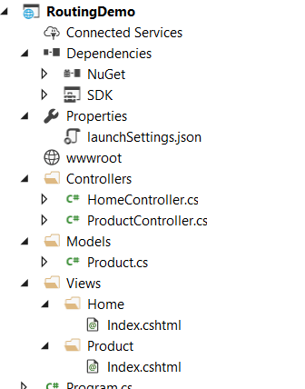

1. **Add AspNetcore.Mvc and AspNetCore.Routing as nugget package**

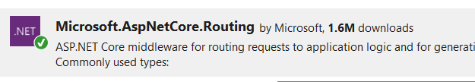

1. **HomeController code**

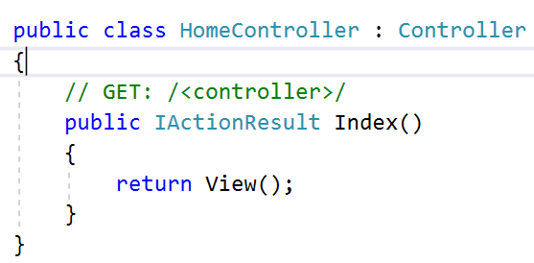

1. **ProductController Code.**

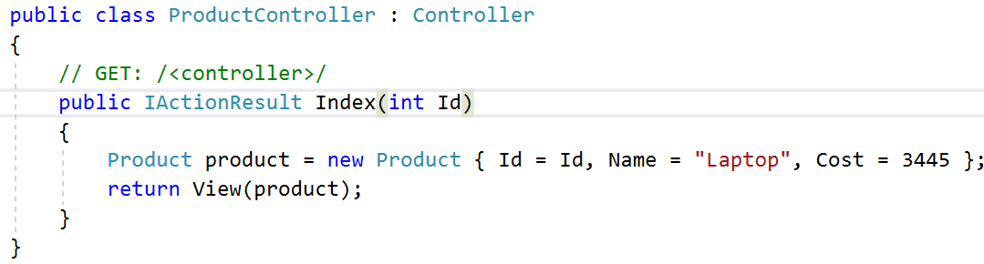

1. **Go to start up and define default routes , we have 2 ways of doing that.**

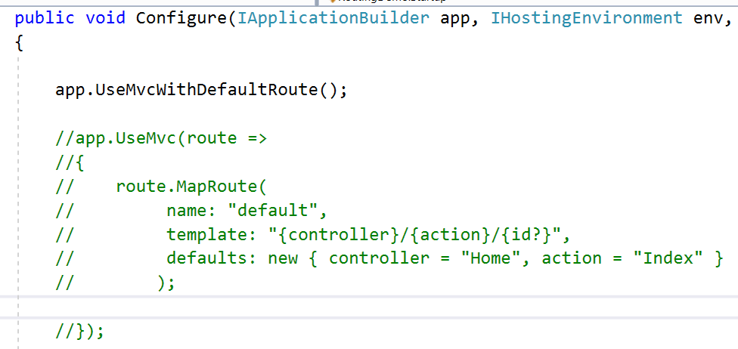

1. **Output.**

**Visit : Product/Index/14**

**Product/Index**

**Product**

**Conventional Routing**

* **Its called as conventional routing because it establishes convention for URL paths**

1. **First Path Segment maps to controller name**
2. **Second is action name**
3. **Third segment is model identity.**

**Attribute Routing**

* **It uses set of attributes to map actions directly to route templates**

**Demo : How to Set Attribute Routing**

1. **Change the route of HomeController**

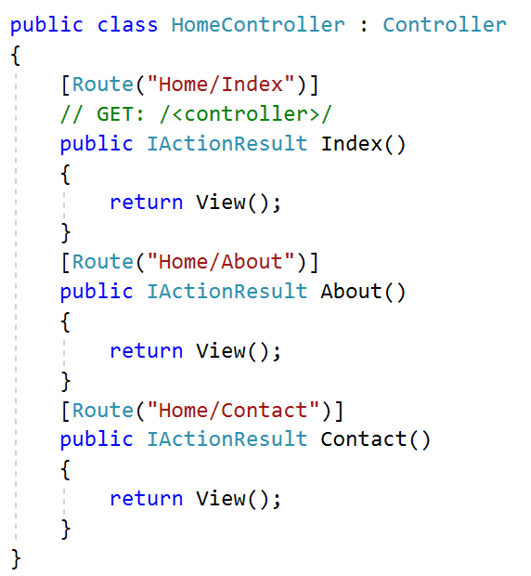

1. **You can Go to Home/Index.. Home/About or Home/Contact**
2. **Set a Default Route**

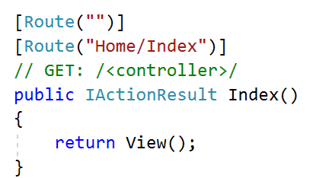

1. **Now Default Route is Home/Index Set**
2. **But you can visit Home route now**

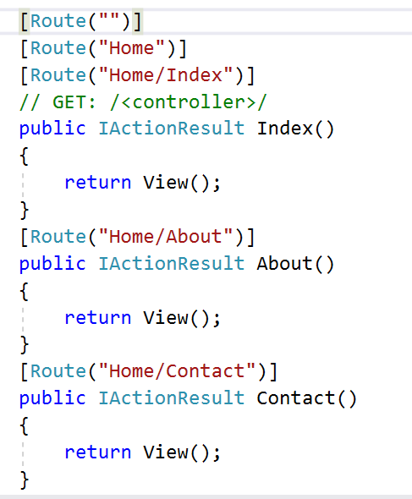

1. **Add Routing in ProductController with Optional Routing**

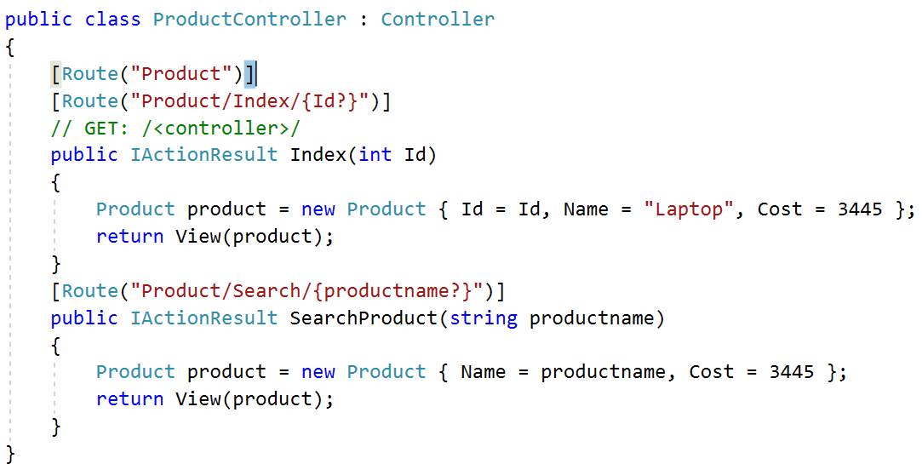

1. **Now you can visit to every route. Check the Output.**
2. **Route Constraint can be used to pass the valid data in the route parameter**

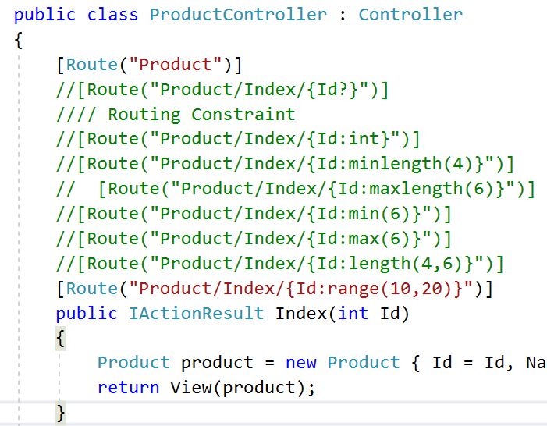

1. **Check each and every route parameter.**